NAME:K.V.SAI KRISHNA
REG.NO:192325037
SUB.CODE:ITA0435

1.Create numeric, character, and logical vectors and display type and content.
Program:
num_vec <- c(10, 20, 30, 40)
print(num_vec)
print(typeof(num_vec))
char_vec <- c("AI", "ML", "NLP")
print(char_vec)
print(typeof(char_vec))
log_vec <- c(TRUE, FALSE, TRUE)
print(log_vec)
print(typeof(log_vec))
OUTPUT:-
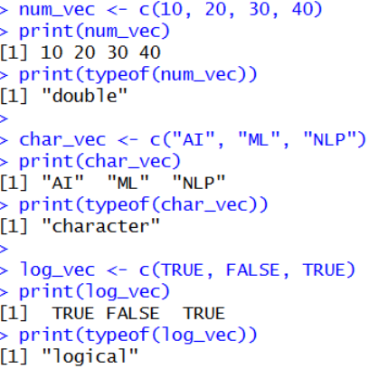

2.Create labelled matrices (5×4, 3×3, 2×2) filled by row/column.
Program:
m1 <- matrix(1:20, nrow=5, ncol=4, byrow=TRUE)
rownames(m1) <- paste("R",1:5,sep="")
colnames(m1) <- paste("C",1:4,sep="")
print(m1)
m2 <- matrix(1:9, nrow=3, ncol=3, byrow=FALSE)
rownames(m2) <- c("A","B","C")
colnames(m2) <- c("X","Y","Z")
print(m2)
m3 <- matrix(c(5,6,7,8), nrow=2, byrow=TRUE)
rownames(m3) <- c("Row1","Row2")
colnames(m3) <- c("Col1","Col2")
print(m3)
Output:-
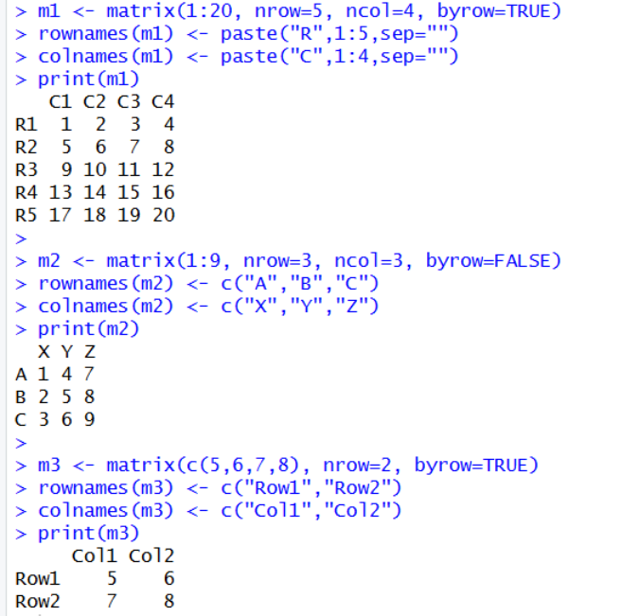

3.Write an R program to create and display a 3D array with specified rows, columns, and tables.
Program:
arr <- array(1:12, dim=c(2,3,2))
print(arr)
Output:-
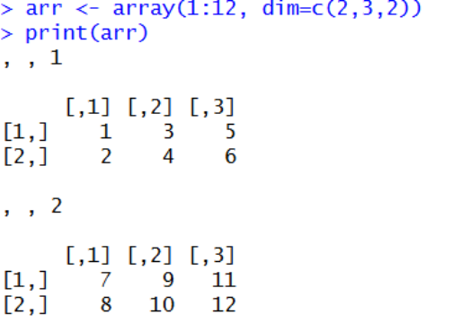
4.Create arrays from vectors with dimension names, print specific elements.
Program:
vec <- c(10,20,30,40,50,60)
arr2 <- array(vec,
dim=c(2,3),
dimnames=list(
Rows=c("R1","R2"),
Cols=c("C1","C2","C3")
))
print(arr2)
print(arr2["R2","C3"])

Output:-
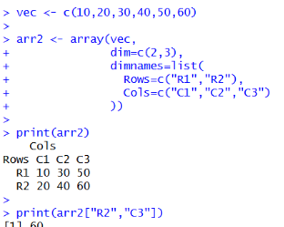
5. Create and manipulate factor variables (e.g., women’s dataset heights, random LETTERS sample).
Program:
data(women)
height_cat <- cut(women$height, breaks=3,
labels=c("Short","Medium","Tall"))
print(height_cat)
print(levels(height_cat))
set.seed(10)
letters_sample <- sample(LETTERS[1:5], 10, replace=TRUE)
letter_factor <- factor(letters_sample)
print(letter_factor)
print(levels(letter_factor))

Output:-
